This is a proposed ‘Preliminary’ outline of the Posturator app STAGE 1.

I’m open to any suggestions/corrections you can make to improve the user experience.

---

STAGE 2. Will be focused on Daily interaction with the user.

I need help

I’m uncomfortable

I’m in pain…

I’d like to make it softer/harder

STAGE 3. Will be focused on the user’s improvements. Responding with encouraging messages and new instructions for the settings.

-----------------------------------------------------

Questions for users of the Posturator IOT App

Qualification Stage

(Presuming their contact info is already

captured and/or they’ve signed in)

“Is the Posturator right for me?”

“The Posturator is designed to help correct and maintain good posture. It can correct varying degrees of: Kyphosis (Hunchback) which is often associated with neck and shoulder pain. It can also help correct a herniated (Slipped) disc. However, I will not help correct Scoliosis. You can track your improvements as you go.

- [Hunchback] (Kyphosis)

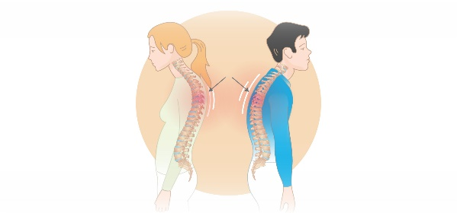

Kyphosis is a spinal deformity that causes an abnormal forward curve in the upper back. It can make the back appear rounded or hunched, and is sometimes called hunchback.

- [Slipped Disc] (Herniated Disc)

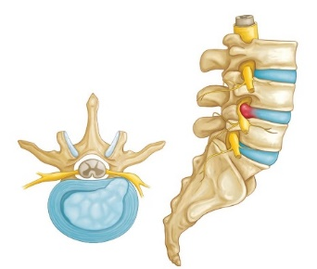

Is when a spinal disc bulges out of place and puts pressure on the spinal cord or nearby nerves. This typically occurs at the lower vertebrae of the spine.

- [Scoliosis]

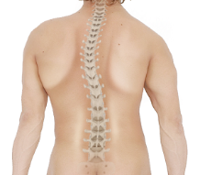

Scoliosis is a spinal deformity that causes the spine to curve sideways into an abnormal "C" or "S" shape.

If you have great posture, the Posturator will help maintain it by preventing slouching and keeping your spine properly aligned”.

“Let’s begin with a few

simple questions, then we’ll

recommend the usage regimen.”

Begin now

---------------------------------------------------

(Question **1**.) ”Do you have existing spine related issues?”

YES NO

(Question **0**.) ”Do you have a clinical diagnosis of your condition prepared by a qualified medical professional?”

YES NO

(If Question **0.** Answer YES), then response **Q1.a**

**Q1.a**- “Can you provide The X-Rays and/or doctor’s report so we can determine whether you can ideally use the Posturator to improve your posture without causing further damage or aggravating existing issues?”

YES NO

(If Question **Q1.a** Answer YES), then response **1.b**

**1.b** -

* “Click hear to upload” (PDF, JPG…)
* “We will contact you shortly after reviewing your documents with a recommendation”.

*COMMENT: This upload & communication should be recorded with an intake form on our website so that we can either notify a health professional OR respond ourselves.*

(If Question **Q1.a** Answer NO), *That means that they DO have existing clinical report BUT they don’t want to share.*  Then, response **Q-1.c**:

**OR**

(If Question **0.** Answer YES), then ask **Q1.c**

**Q-1.c -**  “Would you like to proceed by your own volition to try the Posturator seat cushion?”

YES NO

(If Question **Q-1.c** Answer NO) That means this product is not for them. EXIT the app with the message: **1.d**.

**1.d** - **“Thank you for visiting, we hope to have a product for you soon.”**

(If Question **Q-1.c** Answer YES),

then Move to Question **Q2.**

(If Question **Q-1.c -** Answer NO), then Move to Question **Q2.**

---------------------------------------------------------------

(Question **Q2.**) - Do you have any obvious back pain?

YES NO

(If Question **Q2.** Answer YES), then ask Question **Q 2.a**

**Q 2.a** “Select the pain area that best matches your condition:”

*- Show the following choices*

*with radio buttons (Or similar)*

- [LB Pain] Lower back (Lumbar)

- [MB Pain] Mid back (Thoracic)

- [USN Pain] Upper Spine and Neck area (Cervical)

- [SA Pain] Shoulder area

- [NA Pain] Neck area

(If Question **Q2.a** Answer is [USN Pain] OR [SA Pain] OR [NA Pain]

Then, in the recommendation at the end we’ll include (Add) the text:

“As you lean back and recline, make sure to leave your shoulder and neck muscles relaxed and allow gravity to pull your shoulders backward relative to your spine.”

(If Question **Q2.a** Answer is [LB Pain] and/OR [MB Pain]), then ask Question **Q2.b**

**Q2.b** “Do you have a slipped (Herniated) disc?” [Herniated disc]

YES NO

(If Question **Q2.b** Answer is YES) then, because of the tag [Herniated disc] When making the recommendation at the end, we should add the following phrase with the image:

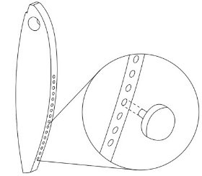 **Q2.b** YES [Herniated Disc]

“Use a ‘spine-nodule’ inserted into the position on the ‘spine-profile’ that matches the height of your herniated disc (Sold separately).

Begin using the Posturator with minimum strain at your own pace. Then increase the usage as your body becomes accustomed to it and the pain is reduced.”

(If Question **Q2.b** Answer is NO AND

(If Question **Q2.a** Answer is YES [LB Pain] [MB Pain] [USN Pain], [SA Pain] or [NA Pain]),

then, When making the recommendation at the end, we should ADD the following message:

**(Q2.a YES) – (Q2.b** NO) message:

“Begin using the Posturator with minimum strain at your own pace. Then increase the usage as your pain is reduced.”

*(If Question* **Q2.a** *Answer is* NO*) They do NOT have any obivious back pain. They are ready to start using the Posturator with very low risk.*

--------------------------------------------------------------------------------

**EXCLUSIONARY QUESTIONS**

Question 3.

- “Are you over the age of 12 years?”

(If NO), Then show the message:

“The Posturator is only for use above age 12.”

Question 4.

- “What is your height?” (Imperial or metric option)

*(User fills in their height)*

(If their height is above 6’5” or 200cm) Show the message:

“You are too tall for this product. Try a more appropriate product”

(If their height is below 4’ or 121cm) Show the message:

“You are too short for this product. For safety, try a more appropriate product.”

Question 5.

- “What is your weight?” (Pound or Kilogram option)

*(User fills in their weight)*

*(If their weight is above 250 pounds or 114Kg), show the message:*

“You are too heavy for this product. For safety, try a more appropriate product.”

Question 6.

- What is your waist size? (Inch or Centimeter option)

*(User fills in their waist size)*

*(If their waist size is above 170 inches or 432cm), show the message:*

“You are large for this product. For safety, try a more appropriate product.”

*------------------------------------------------------------------------------*

Question **Q7.**

- **Do you have a hunchback condition?**

YES NO

If YES, ask the following Question **Q7a.**

:

“Select the posture in this image that best matches your current posture. This will be your ‘Baseline’. In other words – our starting point, from which you will track your improvements.”

*Image coming soon. Meanwhile let’s*

*use placeholders for the*

*10 HUNCHBACK (Kyphotic) postures.*

IMAGE Hunchback [H1] to Worst [H10]

0-Normal

1- H1

2- H2

3- H3

4- H4

5- H5

6- H6

7- H7

8- H8

9- H9

10- H10

If Question **Q7a.** response is:

[Normal]

or [H1]

or [H2]

or [H3]

or [H4]

Then, When making the recommendation at the end, NO additional message:

If Question **Q7a.** response is:

[H5]

or [H6]

or [H7]

or [H8]

Then, When making the recommendation at the end, we should ADD the following message:

“When using the Posturator for correction, it’s important to start at a slow pace. Your seat-time should be 1-3 hrs. per day and you should alternate between different recline angles every 30 to 45 minutes until your body becomes accustomed to it. As your spinal muscles and ligaments become more limber from stretching, you can then increase your seat-time to your comfort. Make sure your pelvis and spine make firm positive contact with the cushion. Ideally, you want to be reclined (With a headrest) in a relaxed and limp condition so your muscles and ligaments can form to the corrective structural position.”

If Question **Q7a.** response is:

[H9]

or [H10]

Then, When making the recommendation at the end, we should ADD the following message:

“When using the Posturator for correction, it’s important to start at a slow pace. Your seat-time should be 1-3 hrs. per day and you should alternate between different recline angles every 30 to 45 minutes until your body becomes accustomed to it. As your spinal muscles and ligaments become more limber from stretching, you can then increase your seat-time to your comfort. Make sure your pelvis and spine make firm positive contact with the cushion. Ideally, you want to be reclined (With a headrest) in a relaxed and limp condition so your muscles and ligaments can form to the corrective structural position.”

Question **Q8.**

- **Do you have a Tilted Pelvis (Lordotic) condition?**

YES NO

If YES, ask the following Question **8a.**:

“Select the pelvic tilt in this image that best matches your current condition. This will be your ‘Baseline’. In other words – our starting point, from which you will track your improvements.”

*Image coming soon. Meanwhile let’s*

*use placeholders for the*

*2 Pelvic tilt (Lordotic) conditions.*

IMAGE Lordotic [Normal] [L1 Lordotic] or [L2 Flatback]

0-Normal

1- [L1]

2- [L2]

If Response for Question **8a.** is [L1], Then the user has: Lordosis (Forward tilting pelvis).

Then, when making the recommendation at the end, we should ADD the following message:

“When using the Posturator, make sure to sit with your pelvis in a neutral position (Not tilted forward) relative to your spine.

If Response for Question **8a.** is [L2], Then the user has: Flatback (Backward tilting pelvis).

Then, when making the recommendation at the end, we should ADD the following message:

“When using the Posturator, make sure to sit with your pelvis in a neutral position (Not tilted backward) relative to your spine.

----------------------------------------------------------------------------

**TRIAGE REFERENCE** (FYI)

**LOW RISK USERS**

If Response for Question **Q1.** is NO, Then the user has:

- NO Posture issues. Normal Posture.

If Response for Question **Q 2.a** is NO, Then the user has:

- No Obvious pain areas.

If Responses for Questions **Q7.** is NO, Then the user is:

- NOT Hunchback

If Response for Question **Q7a.** is [H1 to H4] then, the user has minimal hunchback condition.

1- H1

2- H2

3- H3

4- H4

If Responses for Question **Q8.** is NO, Then the user is:

- NOT Lordotic (Tilted Pelvis)

If Responses for Question **8a.** is[L1 Lordotic] or [L2 Flatback] , Then the user has: Pelvis tilting forward OR backward. But it’s not risky.

(See Message).

---

**MEDIUM RISK USERS**

If Response for Question **Q1.c -** is YES, Then the user:

- DOES have a condition but is NOT Disclosing their medical files, BUT STILL WISHES TO USE THE POSTURATOR by their own volition.

- This will require this additional message in their recommendations…

“Proceed with caution due to your existing condition. Do not over-strain yourself.”

If Response for Question **Q2.a** is YES, Then the user has:

- Obvious pain areas

- [LB Pain] Lower back (Lumbar)

- [MB Pain] Mid back (Thoracic)

Then, they have some obvious pain in these areas. - This will require this additional message in their recommendations…

:

“Begin using the Posturator with minimum strain at your own pace. Then increase the usage as your pain is reduced.”

- [USN Pain] Upper Spine and Neck area (Cervical)

- [SA Pain] Shoulder area

- [NA Pain] Neck area

Then, they have some obvious pain in these areas. - This will require this additional message in their recommendations…

:

“As you lean back and recline, make sure to leave your shoulder and neck muscles relaxed and allow gravity to pull your shoulders backward relative to your spine.”

If Question **Q2.b** Answer is YES) then, the user has a [Herniated disc]. –

This will require this additional message in their recommendations…

“Use a ‘spine-nodule’ inserted into the position on the ‘spine-profile’ that matches the height of your herniated disc (Sold separately).

Begin using the Posturator with minimum strain at your own pace. Then increase the usage as your body becomes accustomed to it and the pain is reduced.”

If Response for Question **Q7a.** is [H5 to H8] then, the user has significant hunchback condition.

---

**HIGH RISK USERS**

If Response for Question **Q7a.** is [H9 to H10] then, the user has Extreme hunchback condition.

- There will likely be other complications as well.

=============================================

Recommendations/Suggestions

If user has:

* Normal (Good) Posture
* No Slipped (Herniated) disc
  + (If yes then add the additional recommendations)
* No Pelvic tilt.
  + (If yes then add the additional recommendations)
* No Pain (OR minimal pain in neck, shoulders, back…)
  + (If yes then add the additional recommendations)

- Then, suggest [Spine-Profile ‘A’] with the recommendation that: they make sure to sit with their pelvis in a neutral position (Not tilted forward) so it’s aligned with the natural flow of the spine.

***General (1) Add to all recommendations when suggesting a ‘Spine Profile’.***

“Always do 5-10 minutes of stretching exercises to loosen the pelvis, torso, shoulder and neck muscles and ligaments before using the Posturator.”

“When using the Posturator, make sure your pelvis and spine make firm positive contact with the cushion. Ideally, you want to be reclined (With a headrest) in a relaxed and limp condition so your muscles and ligaments can form to the corrective structural position. Remember to lean back and recline when possible so that your shoulders are pulled backward by gravity. And slightly switch the recline angle every few (30 – 40) minutes to give the stretching muscles a rest. The more you stay in that stretched position, the more your muscles are inclined to hold that position naturally.”

In between uses of the Posturator, strengthening your abdominal and core muscles with specific exercise will really help to correct your pelvic angle to a neutral stance over time.

Exercises that can help loosen relevant muscles include:

* **Flat back**: Lie on your back, inhale deeply, and exhale while pulling your bellybutton in toward your spine. Lower your arm and leg on opposite sides until they're a few inches above the ground, then return to the starting position. Repeat 10 times for 3–5 sets.
* **Yoga**: Many Yoga exercises can be used to stretch your pelvis, spine and neck muscles. The more flexible you are the better for your posture. Pick the easiest ones you prefer and go at your own pace.
* **Dead bug**: Lie on your back, press your lower back into the floor, and lift your arms and legs so your knees are over your hips.
* **Pelvic tilt with exercise ball**: Sit on a ball with your feet flat on the floor and your legs at a 90-degree angle. Tilt your hips forward, then backward while sticking your tailbone out. Repeat 10 times for 3 sets.
* **Plank**: Strengthens your core and can help improve posture and alignment.
* **Neck extension**: Use a towel or band to pull your neck forward, then extend your neck.

You can also try the superman exercise, which involves lying on your stomach and lifting your arms and legs while keeping your hips on the ground.

In addition to exercise, you can try using a spinal decompression device to gently stretch and relieve pressure on your spine.

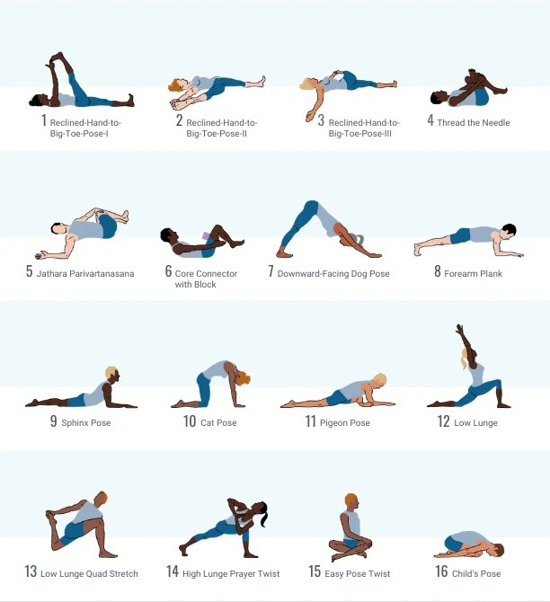

--

- Daily recommended seat time is 1 to 3 hours, and increase gradually at your own pace and tolerance **(Do not overexert your muscles if you’re in pain. Allow your body 2-5 days to get accustomed to the new seating position)**. Typically you can expect to see improvements within 4 to 10 days of consistent use.

***General (2) - Add to the end of all recommendations EXCEPT for NORMAL (GOOD) POSTURE users.***

- Once you see or feel noticeable improvements, You can track your improvements by clicking “Track Improvements”. This will give you an “Improvement Score” and give further instructions. Just follow the prompts.

--------------------------------------------------------------------

If user has:

* Posture Between [H5 to H10] Hunchback
* No Slipped (Herniated) disc
  + (If yes then add the additional recommendations)
* No Pelvic tilt.
  + (If yes then add the additional recommendations)
* No Pain (OR minimal pain in neck, shoulders, back…)
  + (If yes then add the additional recommendations)

- Then, suggest [Spine-Profile ‘A’] with the recommendation that: they make sure to sit with their pelvis in a neutral position (Not tilted forward) so it’s aligned with the natural flow of the spine.

***General (1) Add to all recommendations when suggesting a ‘Spine Profile’.***

“Always do 5-10 minutes of stretching exercises to loosen the pelvis, torso, shoulder and neck muscles and ligaments before using the Posturator.”

“When using the Posturator, make sure your pelvis and spine make firm positive contact with the cushion. Ideally, you want to be reclined (With a headrest) in a relaxed and limp condition so your muscles and ligaments can form to the corrective structural position. Remember to lean back and recline when possible so that your shoulders are pulled backward by gravity. And slightly switch the recline angle every few (30 – 40) minutes to give the stretching muscles a rest. The more you stay in that stretched position, the more your muscles are inclined to hold that position naturally.”

In between uses of the Posturator, strengthening your abdominal and core muscles with specific exercise will really help to correct your pelvic angle to a neutral stance over time.

Exercises that can help loosen relevant muscles include:

* **Flat back**: Lie on your back, inhale deeply, and exhale while pulling your bellybutton in toward your spine. Lower your arm and leg on opposite sides until they're a few inches above the ground, then return to the starting position. Repeat 10 times for 3–5 sets.
* **Yoga**: Many Yoga exercises can be used to stretch your pelvis, spine and neck muscles. Pick the easiest ones you prefer and
* **Dead bug**: Lie on your back, press your lower back into the floor, and lift your arms and legs so your knees are over your hips.
* **Pelvic tilt with exercise ball**: Sit on a ball with your feet flat on the floor and your legs at a 90-degree angle. Tilt your hips forward, then backward while sticking your tailbone out. Repeat 10 times for 3 sets.
* **Plank**: Strengthens your core and can help improve posture and alignment.
* **Neck extension**: Use a towel or band to pull your neck forward, then extend your neck.

You can also try the superman exercise, which involves lying on your stomach and lifting your arms and legs while keeping your hips on the ground.

In addition to exercise, you can try using a spinal decompression device to gently stretch and relieve pressure on your spine.



- Daily recommended seat time is 1 to 3 hours, and increase gradually at your own pace and tolerance **(Do not overexert your muscles if you’re in pain. Allow your body 2-5 days to get accustomed to the new seating position)**. Typically you can expect to see improvements within 4 to 10 days of consistent use.

***General (2) - Add to the end of all recommendations.***

- Once you see or feel noticeable improvements, You can track your improvements by clicking “Track Improvements”. This will give you an “Improvement Score” and give further instructions. Just follow the prompts.

-------------------------------------------------------------------------------

This is a proposed ‘Preliminary’ outline of the Posturator app STAGE 1.

I’m open to any suggestions/corrections you can make to improve the user experience.

---

STAGE 2. Will be focused on Daily interaction with the user.

I need help

I’m uncomfortable

I’m in pain…

I’d like to make it softer/harder

STAGE 3. Will be focused on the user’s improvements. Responding with encouraging messages and new instructions for the settings.